Q: Write a program to encrypt and decrypt Plain text using Vernam Cipher

Ans:

Source Code
#include<iostream>
#include <string>

using namespace std;

// function to encrypt the plain text
void Encrypt(string key, string &s){

for(int i=0;i<s.length();i++){ // iterating over plain text
// checking if character is an alphabet
if(!((s[i]>='a' && s[i]<='z') || (s[i]>='A' && s[i]<='Z'))) continue;

int first_char = islower(s[i]) ? 'a' : 'A',
//converting range from ascii to 0-25
rel_s = s[i]- first_char,
rel_key = key[i]- first_char;

//encrypting text
rel_s+=rel_key;
rel_s%=26;

//changing range back to ascii and storing
s[i]=rel_s + first_char;
}
}

// function to decrypt the plain text
void Decrypt(string key,string &s){

for(int i=0;i<key.length();i++){// iterating over plane text
// checking if character is an alphabet
if(!((s[i]>='a' && s[i]<='z') || (s[i]>='A' && s[i]<='Z'))) continue;

int first_char = islower(s[i]) ? 'a' : 'A',
// decrypting text
rel_s = s[i]- key[i];
if(rel_s<0){
rel_s+=26;
}

//changing range back to ascii and storing
s[i]=rel_s + first_char;
}
}

int main(){
string input, key;
int choose;
cout<<"Enter the plain test:\t";
getline(cin, input); // taking plain text input
cout<<"Enter Key of length "<<input.size()<<":\t";
getline(cin,key); // taking key input
cout<<"To Encrypt enter 1.\nTo Decrypt enter 2.\n";
cin>>choose; // taking command to encrypt or decrypt
if(choose==1){
Encrypt(key,input);
cout<<"Encrypted: "<<input<<endl;
}
else{
Decrypt(key,input);
cout<<"Decrypted: "<<input<<endl;
}
return 0;
}

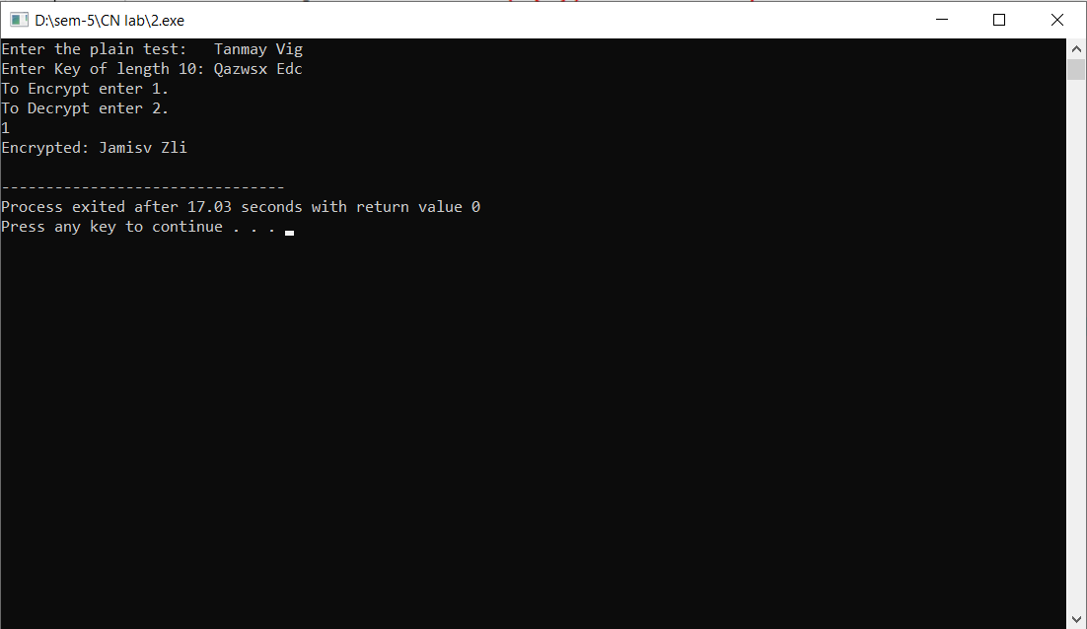
Output:

